Assignment 4



Abdulrahman M Al-Mayouf ID 202002524

Instructor: Dr. Sotirios Zygiaris

Dr. Aamir Abbas Chaudhry

BUSI 3331: Business Analytics

3 / 27 / 2024

Input into Tablau and create linear analysis using MODEL_quantile give it as a name your estimate sales

quantitywith 0.5 on sales TOTALS and quantity TOTALQ (predictor).

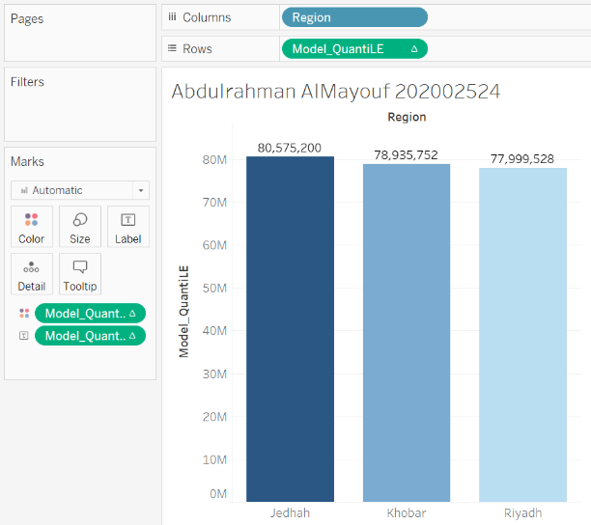

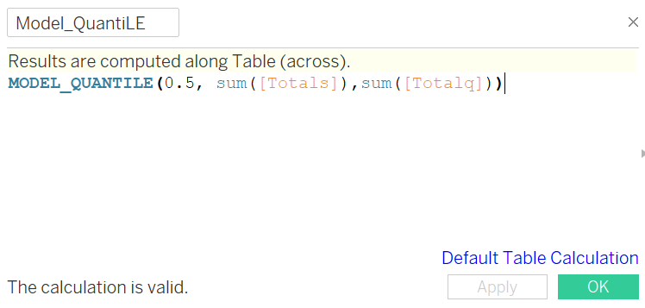

Create a prediction using estimate sales, observed sales and region. Use type and numbers in

Digram

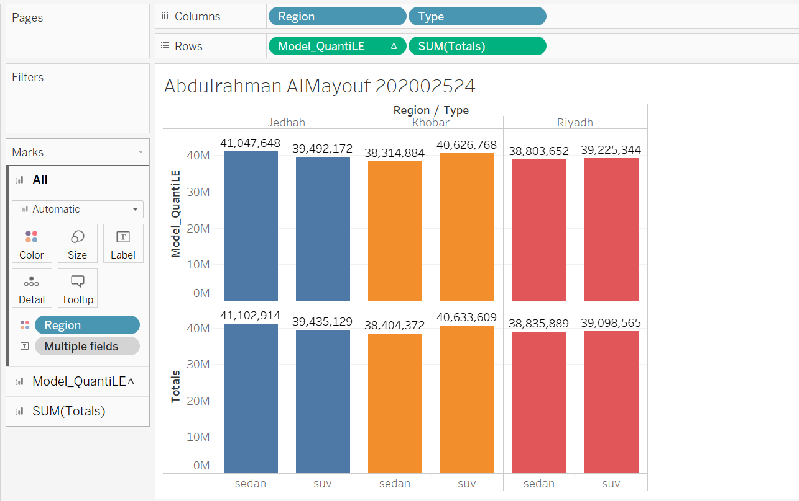

Repeat with brand as variable.

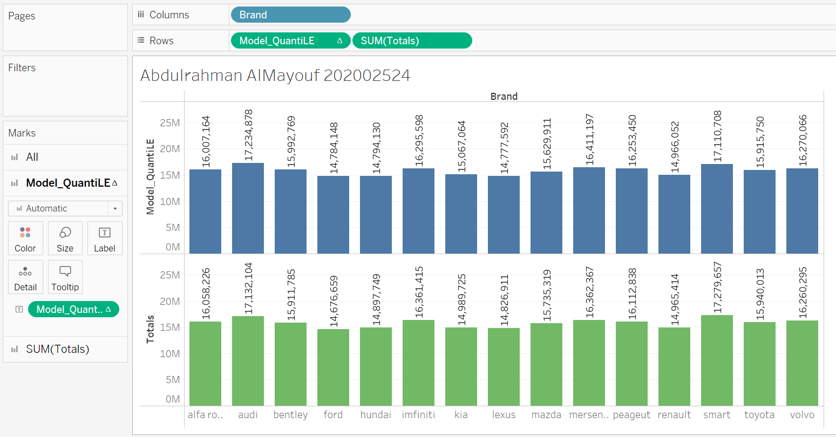

Create upper and lower quantile functions and show the confidence levels for the brand outlay.

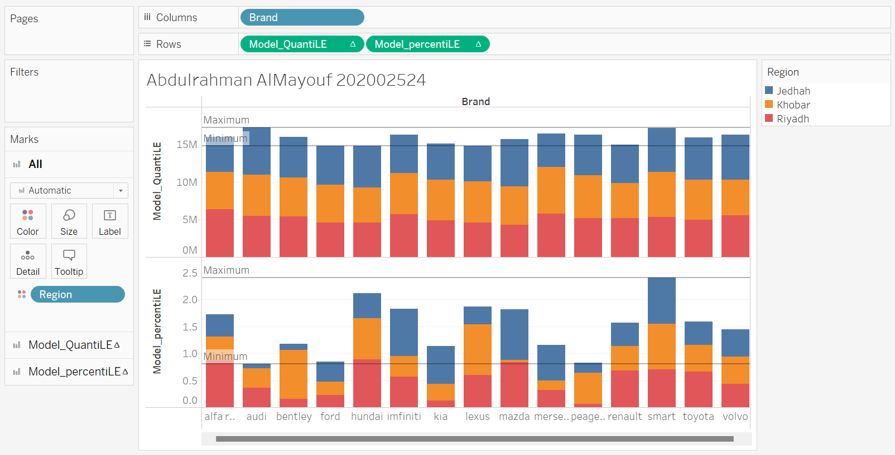

Using the Model percentile() to show the probabilities between sales and band

